ACPT Social Media Toolkit - Oct/Nov 2025
X Posts
X Post 1: Clinician Perspective
ACT NOW: Clinicians like me can't collectively absorb $500M in lost revenue. ACPT — a flawed @CMSgov payment policy — threatens our ability to provide care and keep our communities healthy. @CMSgov must #FixACPTNow. Visit FixACPTNow.org

X Post 2: Community Perspective
URGENT: Health care access in your community is at risk! A flawed @CMSgov policy, ACPT, hasn't kept up with costs. This could strip $500M from 375k+ clinicians — threatening the health of our communities. Protect YOUR access: FixACPTNow.org #FixACPTNow

LinkedIn Posts

LinkedIn Post 1: High-Level Executive Summary

A flawed government policy is silently undermining clinicians and threatening primary care access at a time when over 100 million Americans already face challenges in accessing care.
The Accountable Care Prospective Trend (ACPT) is meant to set fair growth rates for care costs. In its first year, it missed Medicare spending by 48%. Now in 2025, spending is projected to be 90% higher than the ACPT predicted.
This isn't just about numbers—it's about the sustainability of quality care. This flawed trend is reducing crucial revenue for accountable care clinicians, making it difficult for them to invest in the preventive, high-quality care. We must ensure doctors are paid fairly for providing value-based care.
@Centers for Medicare & Medicaid Services (CMS) must retire the ACPT and replace it with a system that accurately reflects economic realities and keeps clinicians in programs that put health outcomes first.
💡 Tell CMS to remove the flawed cost trend and protect the future of value-based care. #FixACPTNow: FixACPTNow.org
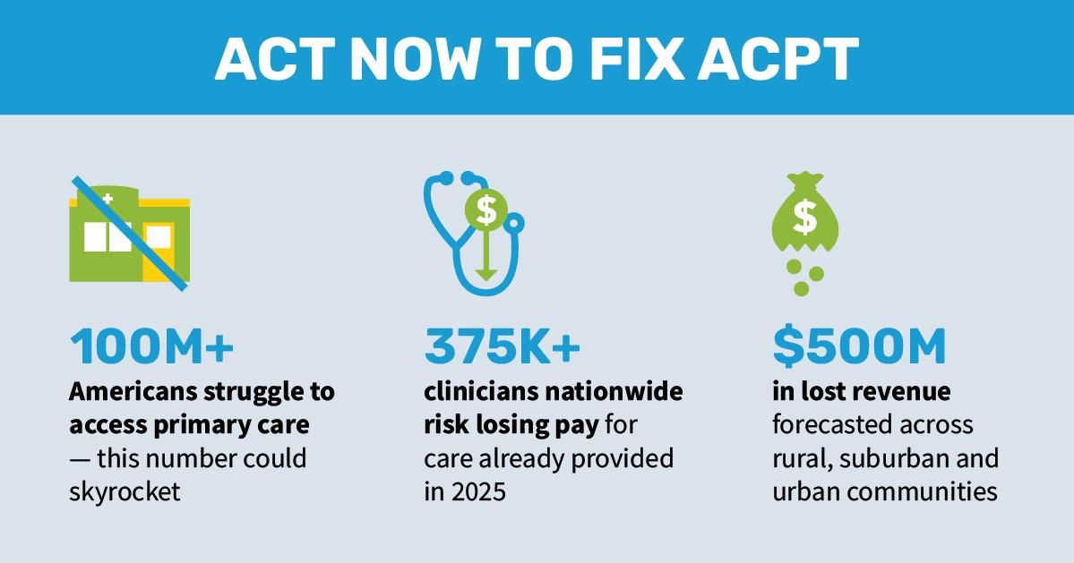

LinkedIn Post 2: Data-Focused
A flawed @Centers for Medicare & Medicaid Services (CMS) policy could cause clinicians to lose compensation for high-quality care they have already provided.
The Accountable Care Prospective Trend (ACPT) — a fixed projected growth rate intended to set benchmarks for ACOs — is becoming a financial liability by poorly predicting the cost of care.
Here are the facts:
🔴 The ACPT underestimated 2024 Medicare spending by 48%. Clinicians consequently lost $154 million in earned revenue, resulting in a 1.3% reduction in ACO benchmarks. That loss came after CMS re-weighted the impact because the projection was so far off the mark.
🔴 Spending for 2025 is currently 90% higher than the ACPT's projection, potentially costing 375,000 clinicians more than $500 million in lost revenue this year alone.
This flawed forecast reduces clinicians' ability to invest in their patients’ health through tools like data analytics and care coordinators that make value-based care successful.
💡 The Solution: @Centers for Medicare & Medicaid Services (CMS) must retire the ACPT and replace it with an accurate trend system that pays clinicians fairly, addresses benchmark "ratchet" and allows ACOs to receive savings adjustments.
✍️ Tell CMS to retire the flawed ACPT before it forces more clinicians out of accountable care. We need data-driven policy that supports, not undermines, value-based care. FixACPTNow.org #FixACPTNow


LinkedIn Post 3: Community Impact
Over 100 million Americans struggle to access the primary care they need. A flawed @Centers for Medicare & Medicaid Services (CMS) policy, the Accountable Care Prospective Trend (ACPT), is making that challenge worse.
This inaccurate projection system could cost 375,000 clinicians more than $500 million in 2025 alone. This isn't just lost revenue—it’s fewer resources to hire care coordinators, upgrade data analytics, and maintain essential patient outreach programs that make value-based care successful.
Forcing clinicians to choose between financial stability and investing in high-quality, preventive care ultimately harms the seniors they serve. We need a system that rewards high-quality, preventive care. Clinicians shouldn't have to worry about a flawed forecast forcing them to make difficult decisions about patient care.
📢 Tell CMS that retiring the flawed ACPT is essential for protecting care in our communities. Find more resources at FixACPTNow.org #FixACPTNow


Facebook

Facebook Post 1: Clinician Perspective
Like so many primary care clinicians, my commitment every single day is to the health of my patients and our community.
It’s because of this commitment that we’ve embraced Medicare programs that reward us for keeping patients healthy and out of the hospital — because we believe it’s the right way to practice medicine.
But right now, 375,000 of us nationwide are facing a critical situation.
A major flaw in how @Medicare is calculating cost trends (called the Accountable Care Prospective Trend or ACPT) means that practices and clinics like mine, which have been providing high-quality care, are at risk of losing the revenue we fairly earned — to the tune of more than $500 million.
To us, this isn't just money — it's the resources that allow us to hire our incredible staff, invest in better patient services, and make sure we have enough time to spend with you during your visits. Without it, many of us will face devastating choices about cutting services or even closing our doors.
Help us tell Medicare not to penalize doctors for their hard work — your support can help protect primary care in our community: FixACPTNow.org #FixACPTNow


Facebook Post 2: Infographic Style
DID YOU KNOW?
A huge flaw could be impacting your health care.
❗️ A @Medicare inflation estimate, the Accountable Care Prospective Trend (ACPT) is off by as much as 90% for primary care costs in 2025.
💰 This mistake takes away nearly $500 MILLION from local doctor's offices across the country.
👩‍⚕️ More than 375,000 clinicians who provide high-quality care could be penalized at a time when 100 million Americans already struggle to access primary care.
This isn't just a budget issue; it’s a direct threat to the stability of primary care in our communities.
Let's make sure CMS understands the real-world impact of their numbers.
Tell Medicare it must retire the flawed ACPT: FixACPTNow.org #FixACPTNow
